1. Is your browser running HTTP version 1.0 or 1.1? What version of HTTP is the server running?

Ans : Browser running HTTP version: 1.1, Server too.

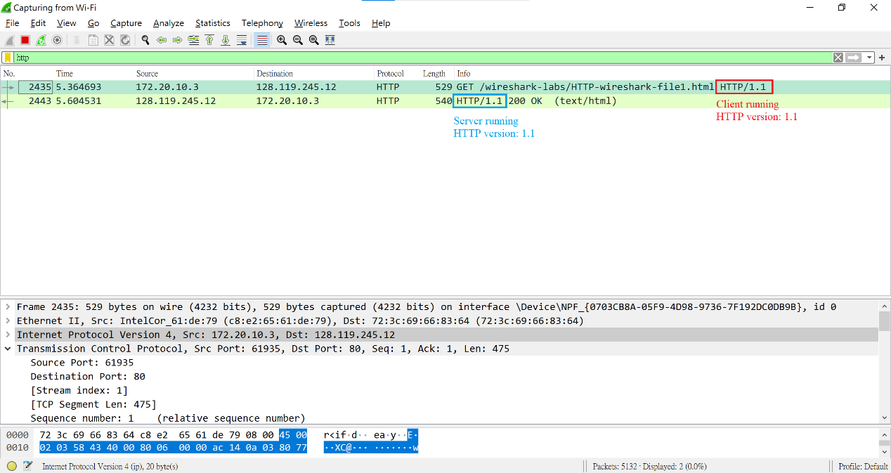

1. What languages (if any) does your browser indicate that it can accept to the server?

Ans : zh-TW, zh; q=0.9.

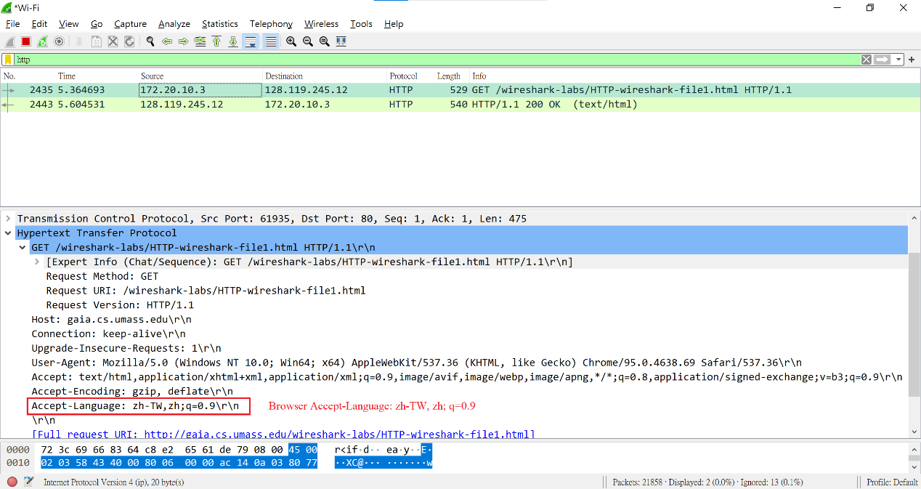

1. What is the IP address of your computer? Of the gaia.cs.umass.edu server?

Ans : My computer Internal IP address:172.20.10.3.

Server External IP address: 128.119.245.12.

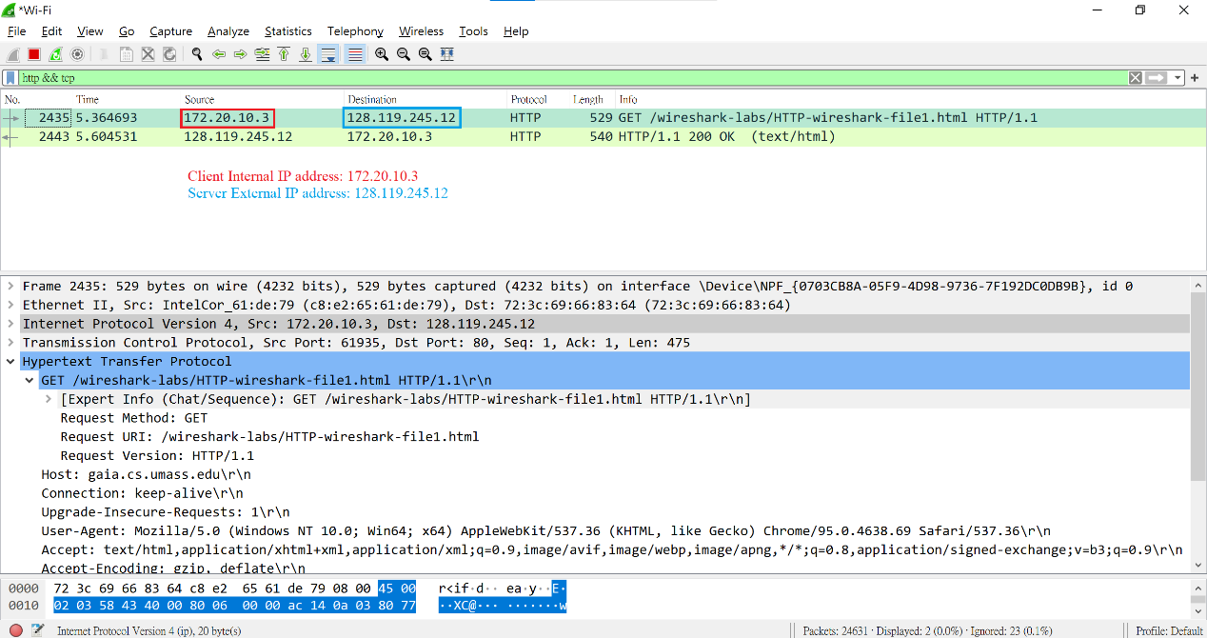

1. What is the status code returned from the server to your browser?

Ans : 200 OK

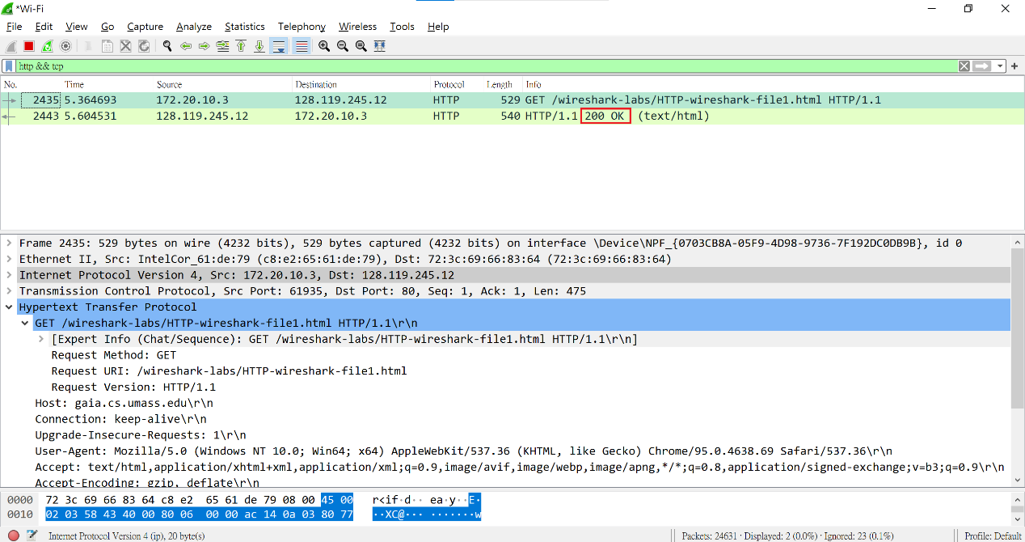

1. When was the HTML file that you are retrieving last modified at the server?

Ans : We can filter messages by http.last_modified and we see that the HTTP response I received for the html file doesn’t show this field. but we do have a http.last_modified field in the favicon response, however, we could found the last modified on “Sat, 13 Nov 2021 06:59:02 GMT”.

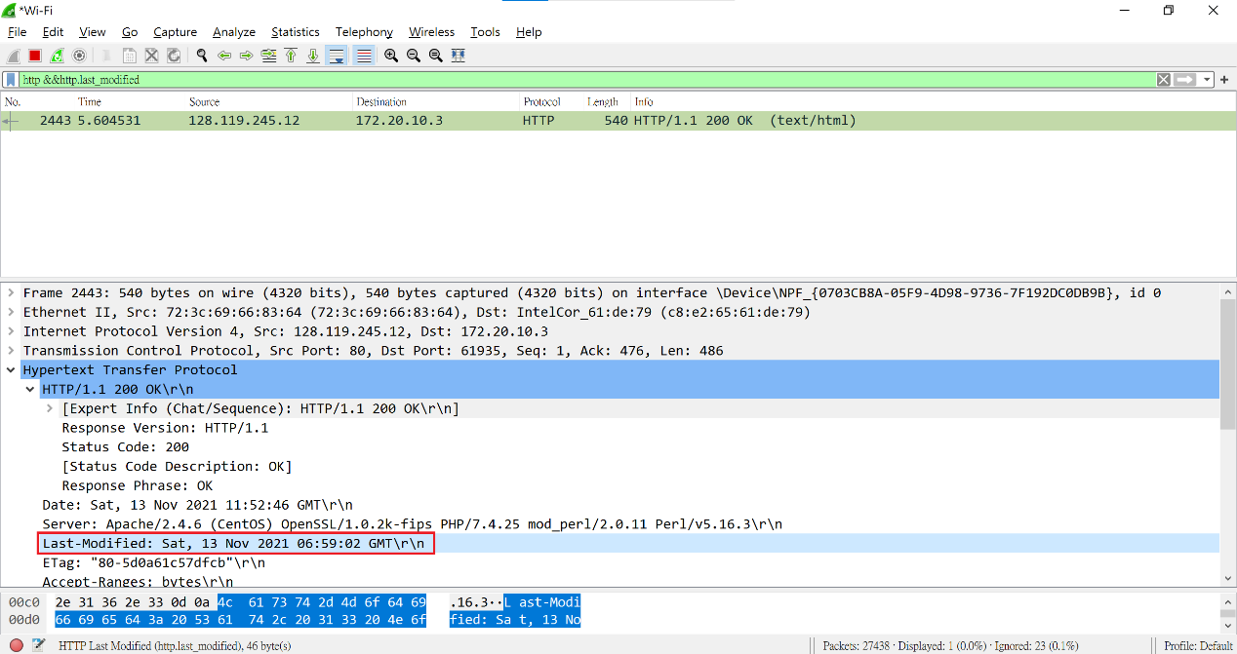

1. How many bytes of content are being returned to your browser?

Ans : 128 bytes

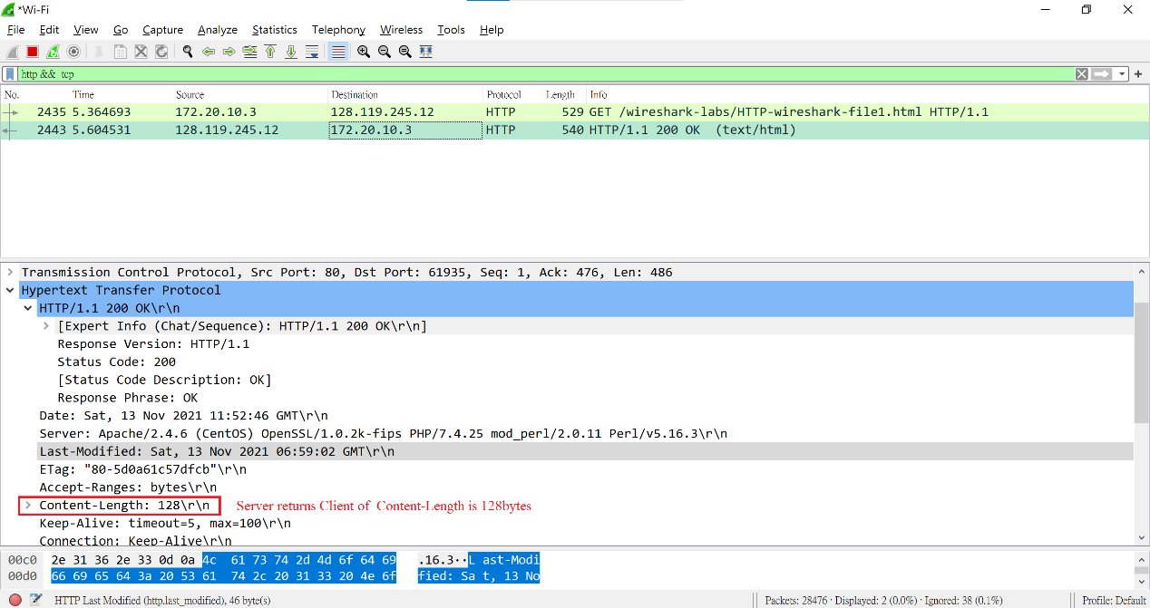

1. By inspecting the raw data in the packet content window, do you see any headers within the data that are not displayed in the packet-listing window? If so, name one.

Ans : No, all of the headers can be found in the raw data.

1. Inspect the contents of the first HTTP GET request from your browser to the server. Do you see an “IF-MODIFIED-SINCE” line in the HTTP GET?

Ans : No, I can’t see “IF-MODIFIED-SINCE” in the HTTP GET.

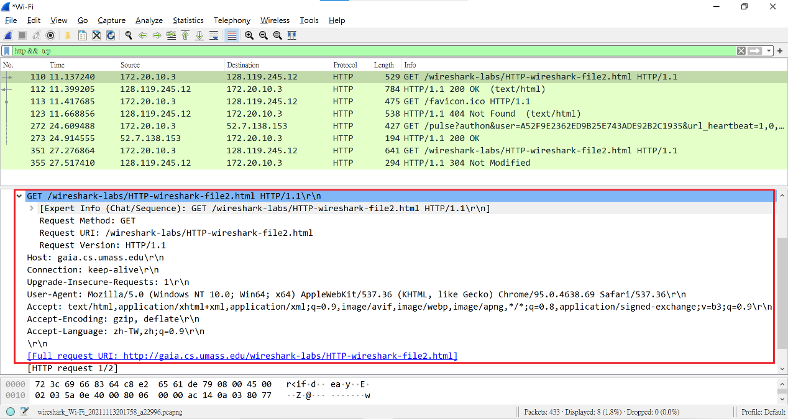

1. Inspect the contents of the server response. Did the server explicitly return the contents of the file? How can you tell?

Ans : Yes, because I could see the content in the “Line-based text data” field and my Browser.

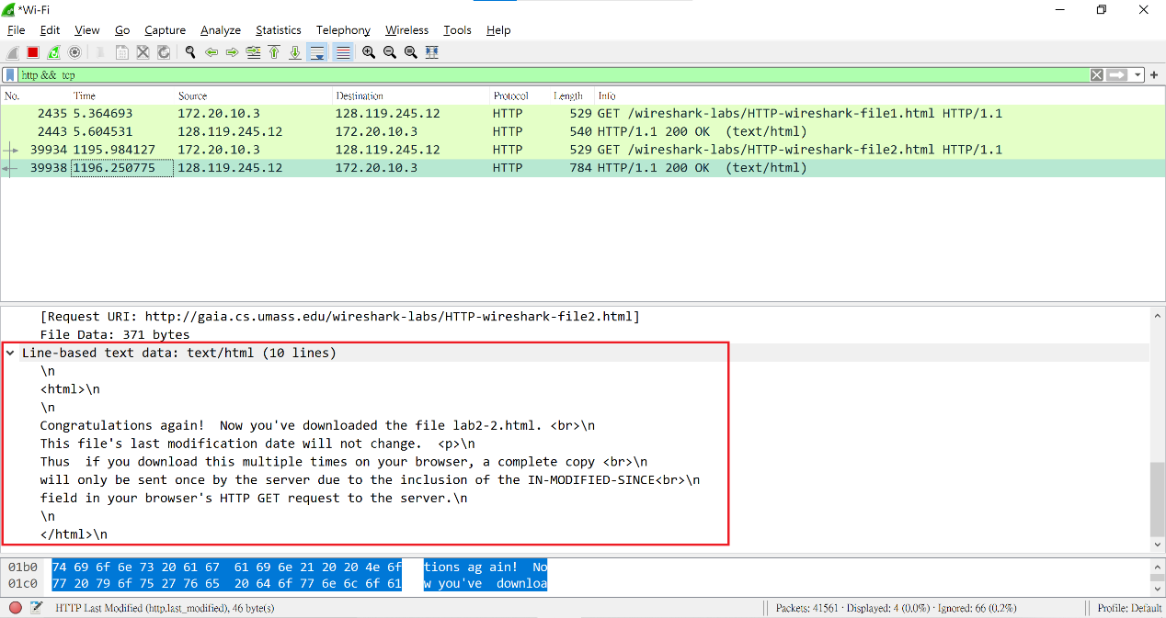

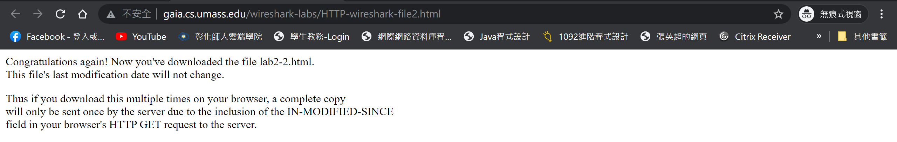

1. Now inspect the contents of the second HTTP GET request from your browser to the server. Do you see an “IF-MODIFIED-SINCE:” line in the HTTP GET? If so, what information follows the “IF-MODIFIED-SINCE:” header?

Ans : Yes, If-Modified-since: Sat, 13 Nov 2021 06:59:02 GMT.

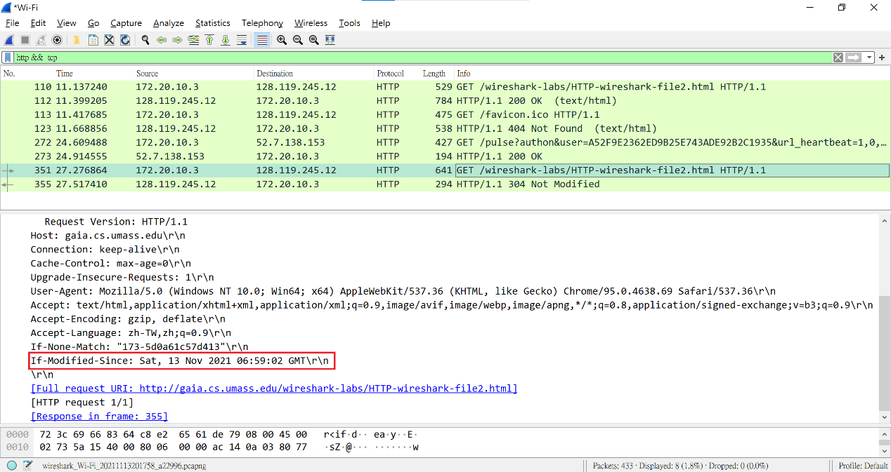

1. What is the HTTP status code and phrase returned from the server in response to this second HTTP GET? Did the server explicitly return the contents of the file? Explain.

Ans : The status code and phrase returned from the server is HTTP/1.1 304 Not Modified. The server didn’t return the contents of the file since the browser loaded it from its cache.

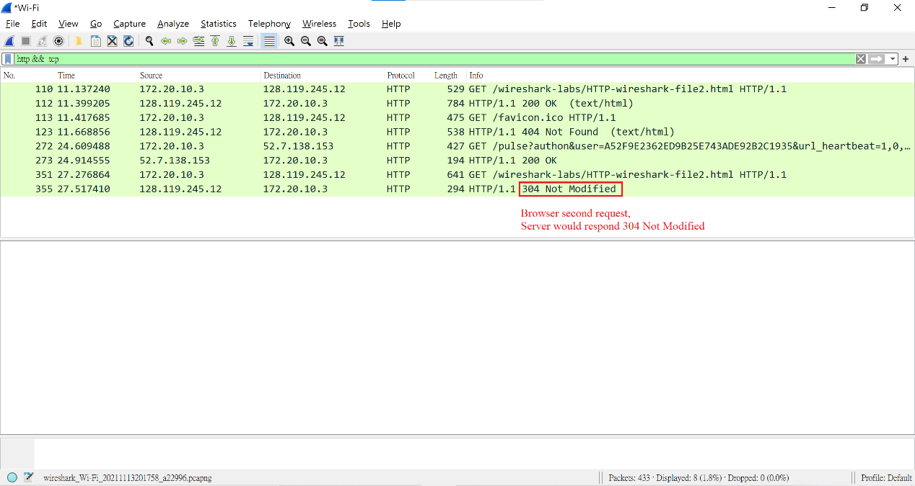

1. How many HTTP GET request messages did your browser send? Which packet number in the trace contains the GET message for the Bill or Rights?

Ans : My browser sent only one HTTP GET request message. Packet number 17 contained the GET message for the Bill of Rights.

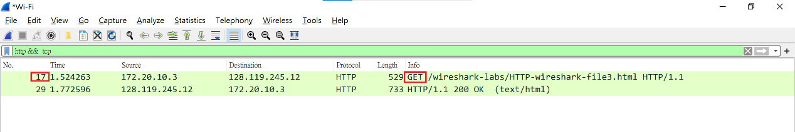

1. Which packet number in the trace contains the status code and phrase associated with the response to the HTTP GET request?

Ans : packet number: 29.

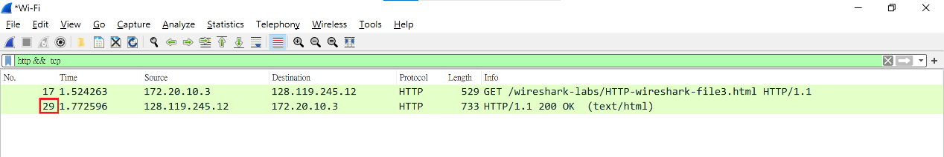

1. What is the status code and phrase in the response?

Ans : if click reboot browser the status is 304 Not Modified

, that first clicked the status is 200 OK.

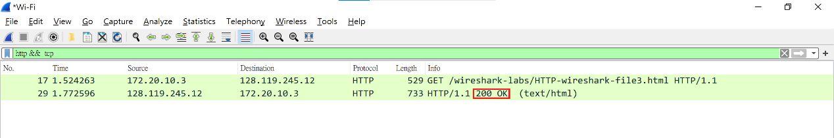

1. How many data-containing TCP segments were needed to carry the single HTTP response and the text of the Bill of Rights?

Ans : 4, Respectively are 1394﹑1394﹑1394 and 679 bytes, total length is 4861 bytes.

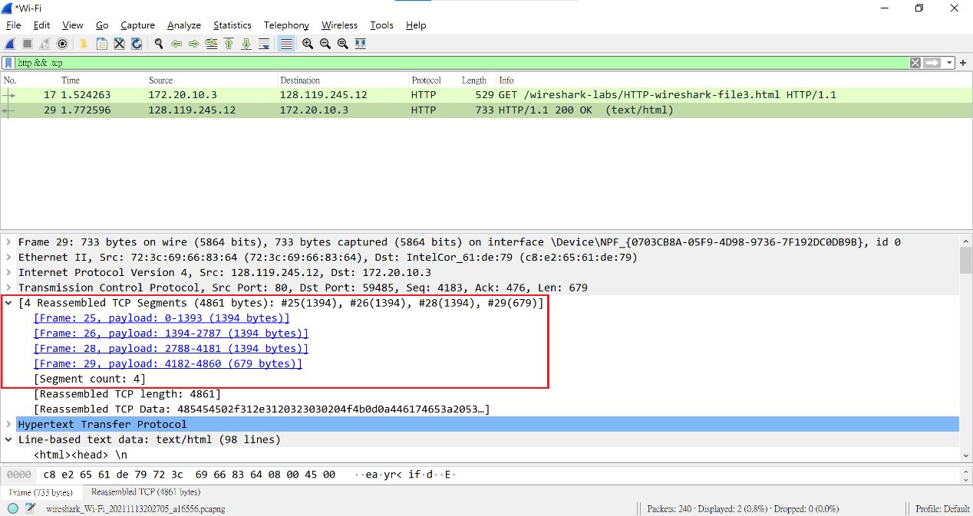

1. How many HTTP GET request messages did your browser send? To which Internet addresses were these GET requests sent?

Ans : 3, Respectively are 128.119.245.12 and 128.119.245.12 and 178.79.137.164.

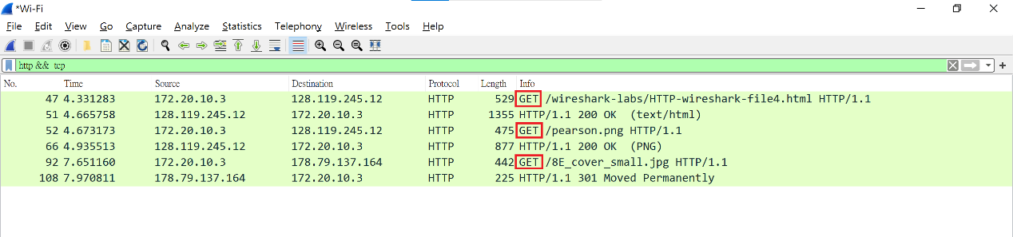

1. Can you tell whether your browser downloaded the two images serially, or whether they were downloaded from the two web sites in parallel? Explain.

Ans : The two pictures downloaded by the browser are downloaded serially. For example, when we download two larger programs, the system sources are shared and exchanged. Because the download speed is fast, the difference may not be visible to the naked eye, but the more works downloaded, the less system resources are allocated, and the easier it is to see that it is a serial download, However, 8E_cover_small.jpg be rewrite his position, so respond 301 Move Permanently.

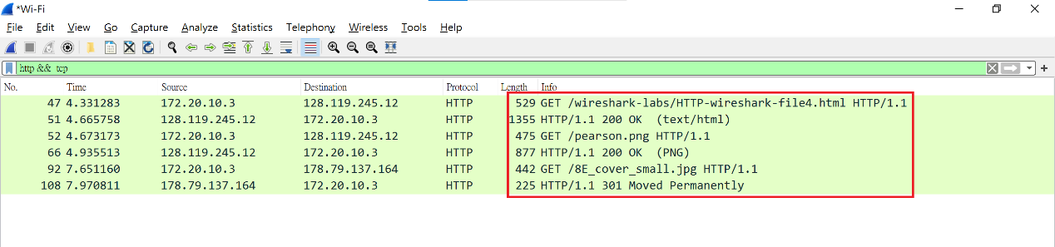

1. What is the server’s response (status code and phrase) in response to the initial HTTP GET message from your browser?

Ans : 401 Unauthorized.

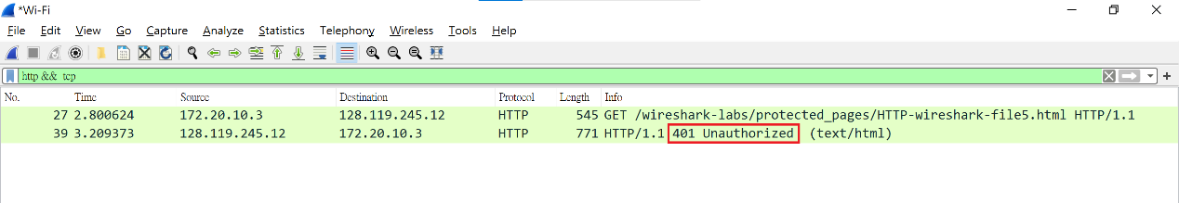

1. When your browser’s sends the HTTP GET message for the second time, what new field is included in the HTTP GET message?

Ans : Authorized field.

